Ex1: Sa se afiseze orasul si codul locatiei in care lucreaza in prezent salariatii angajati pe un job al carui titlu se termina in "clerk" sau care se gaseste intr-o tara a carei denumire are pe a 4-a sau a 5-a pozitie litera "a".

select city, l.location_id

from locations l join countries c on l.country_id = c.country_id

where lower(country_name) like '___a%' or lower(country_name) like '____a%'

union

select distinct city, l.location_id

from countries c join locations l on l.country_id = c.country_id

join departments d on d.location_id = l.location_id

join employees e on e.department_id = d.department_id

join jobs j on e.job_id = j.job_id

where lower(job_title) like '%clerk';

--10 rezultate

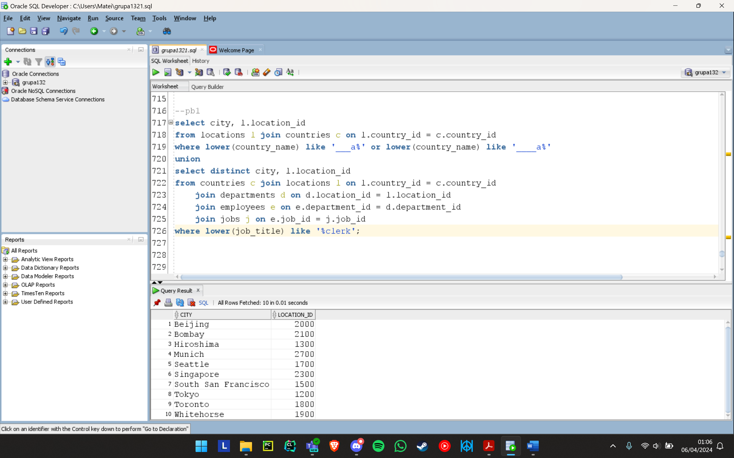

Ex 2a): Sa se afiseze numele complet, job-ul (titlul) actual si departamentul (numele) actual

pentru angajatii care in prezent lucreaza intr-un departament si pe un job

pe care au lucrat in trecut si alti salariati angajati dupa 29-Octombrie-1993.

Se va tine cont atat de job, cat si de departament. Ordonati rezultatele descrescator in functie de codul departamentului si apoi dupa titlul jobului.

select distinct last_name || ' ' || first_name as NUME_COMPLET, job_title, department_name

from employees e1 join departments d1 on e1.department_id = d1.department_id

left outer join job_history jh on e1.employee_id = jh.employee_id

join jobs j1 on e1.job_id = j1.job_id

where (job_title, department_name) in (

select job_title, department_name

from job_history jh join employees e on jh.employee_id = e.employee_id

join jobs j on jh.job_id = j.job_id

join departments d on jh.department_id = d.department_id

where hire_date > '29-OCT-93')

order by department_name, job_title desc;

--55 rezultate

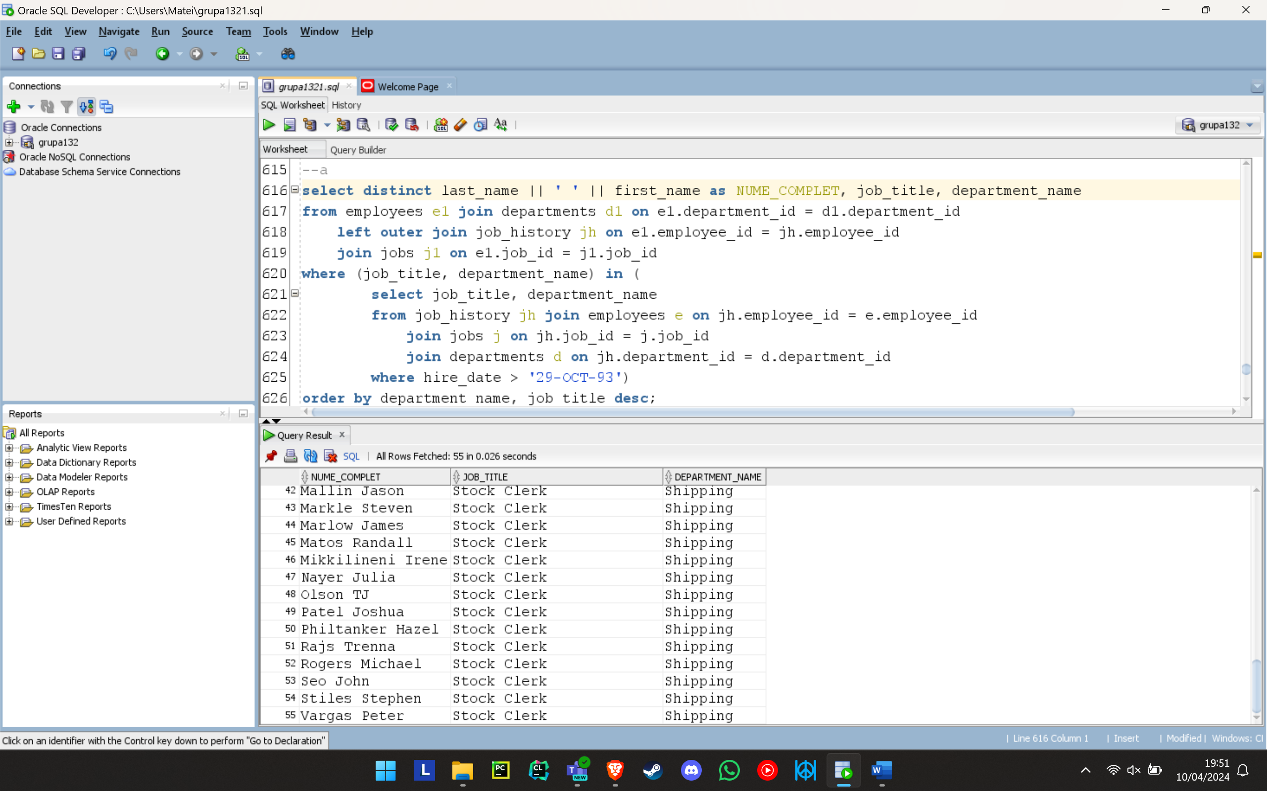

Ex 2b): Modificati cererea anterioara astfel incat sa se tina cont doar de lista job-urilor pe care au lucrat in trecut angajatii indiferent de departamentul in care au lucrat. Discutati diferentele aparute in cod, cat si despre rezultatele obtinute.

select distinct last_name || ' ' || first_name as NUME_COMPLET, job_title, department_name

from employees e1 full outer join departments d1 on e1.department_id = d1.department_id

full outer join job_history jh on e1.employee_id = jh.employee_id

full outer join jobs j1 on e1.job_id = j1.job_id

where job_title in (

select job_title

from job_history jh join employees e on jh.employee_id = e.employee_id

join jobs j on jh.job_id = j.job_id

join departments d on jh.department_id = d.department_id

where hire_date > '29-OCT-93')

order by department_name, job_title desc;

--56 rezultate

Apare in plus fata de cerinta a) inca 1 angajat care are acelasi job dar e in alt departament ca alti salariati angajati dupa 29 oct 1993: Grant Kimberely (departament null)

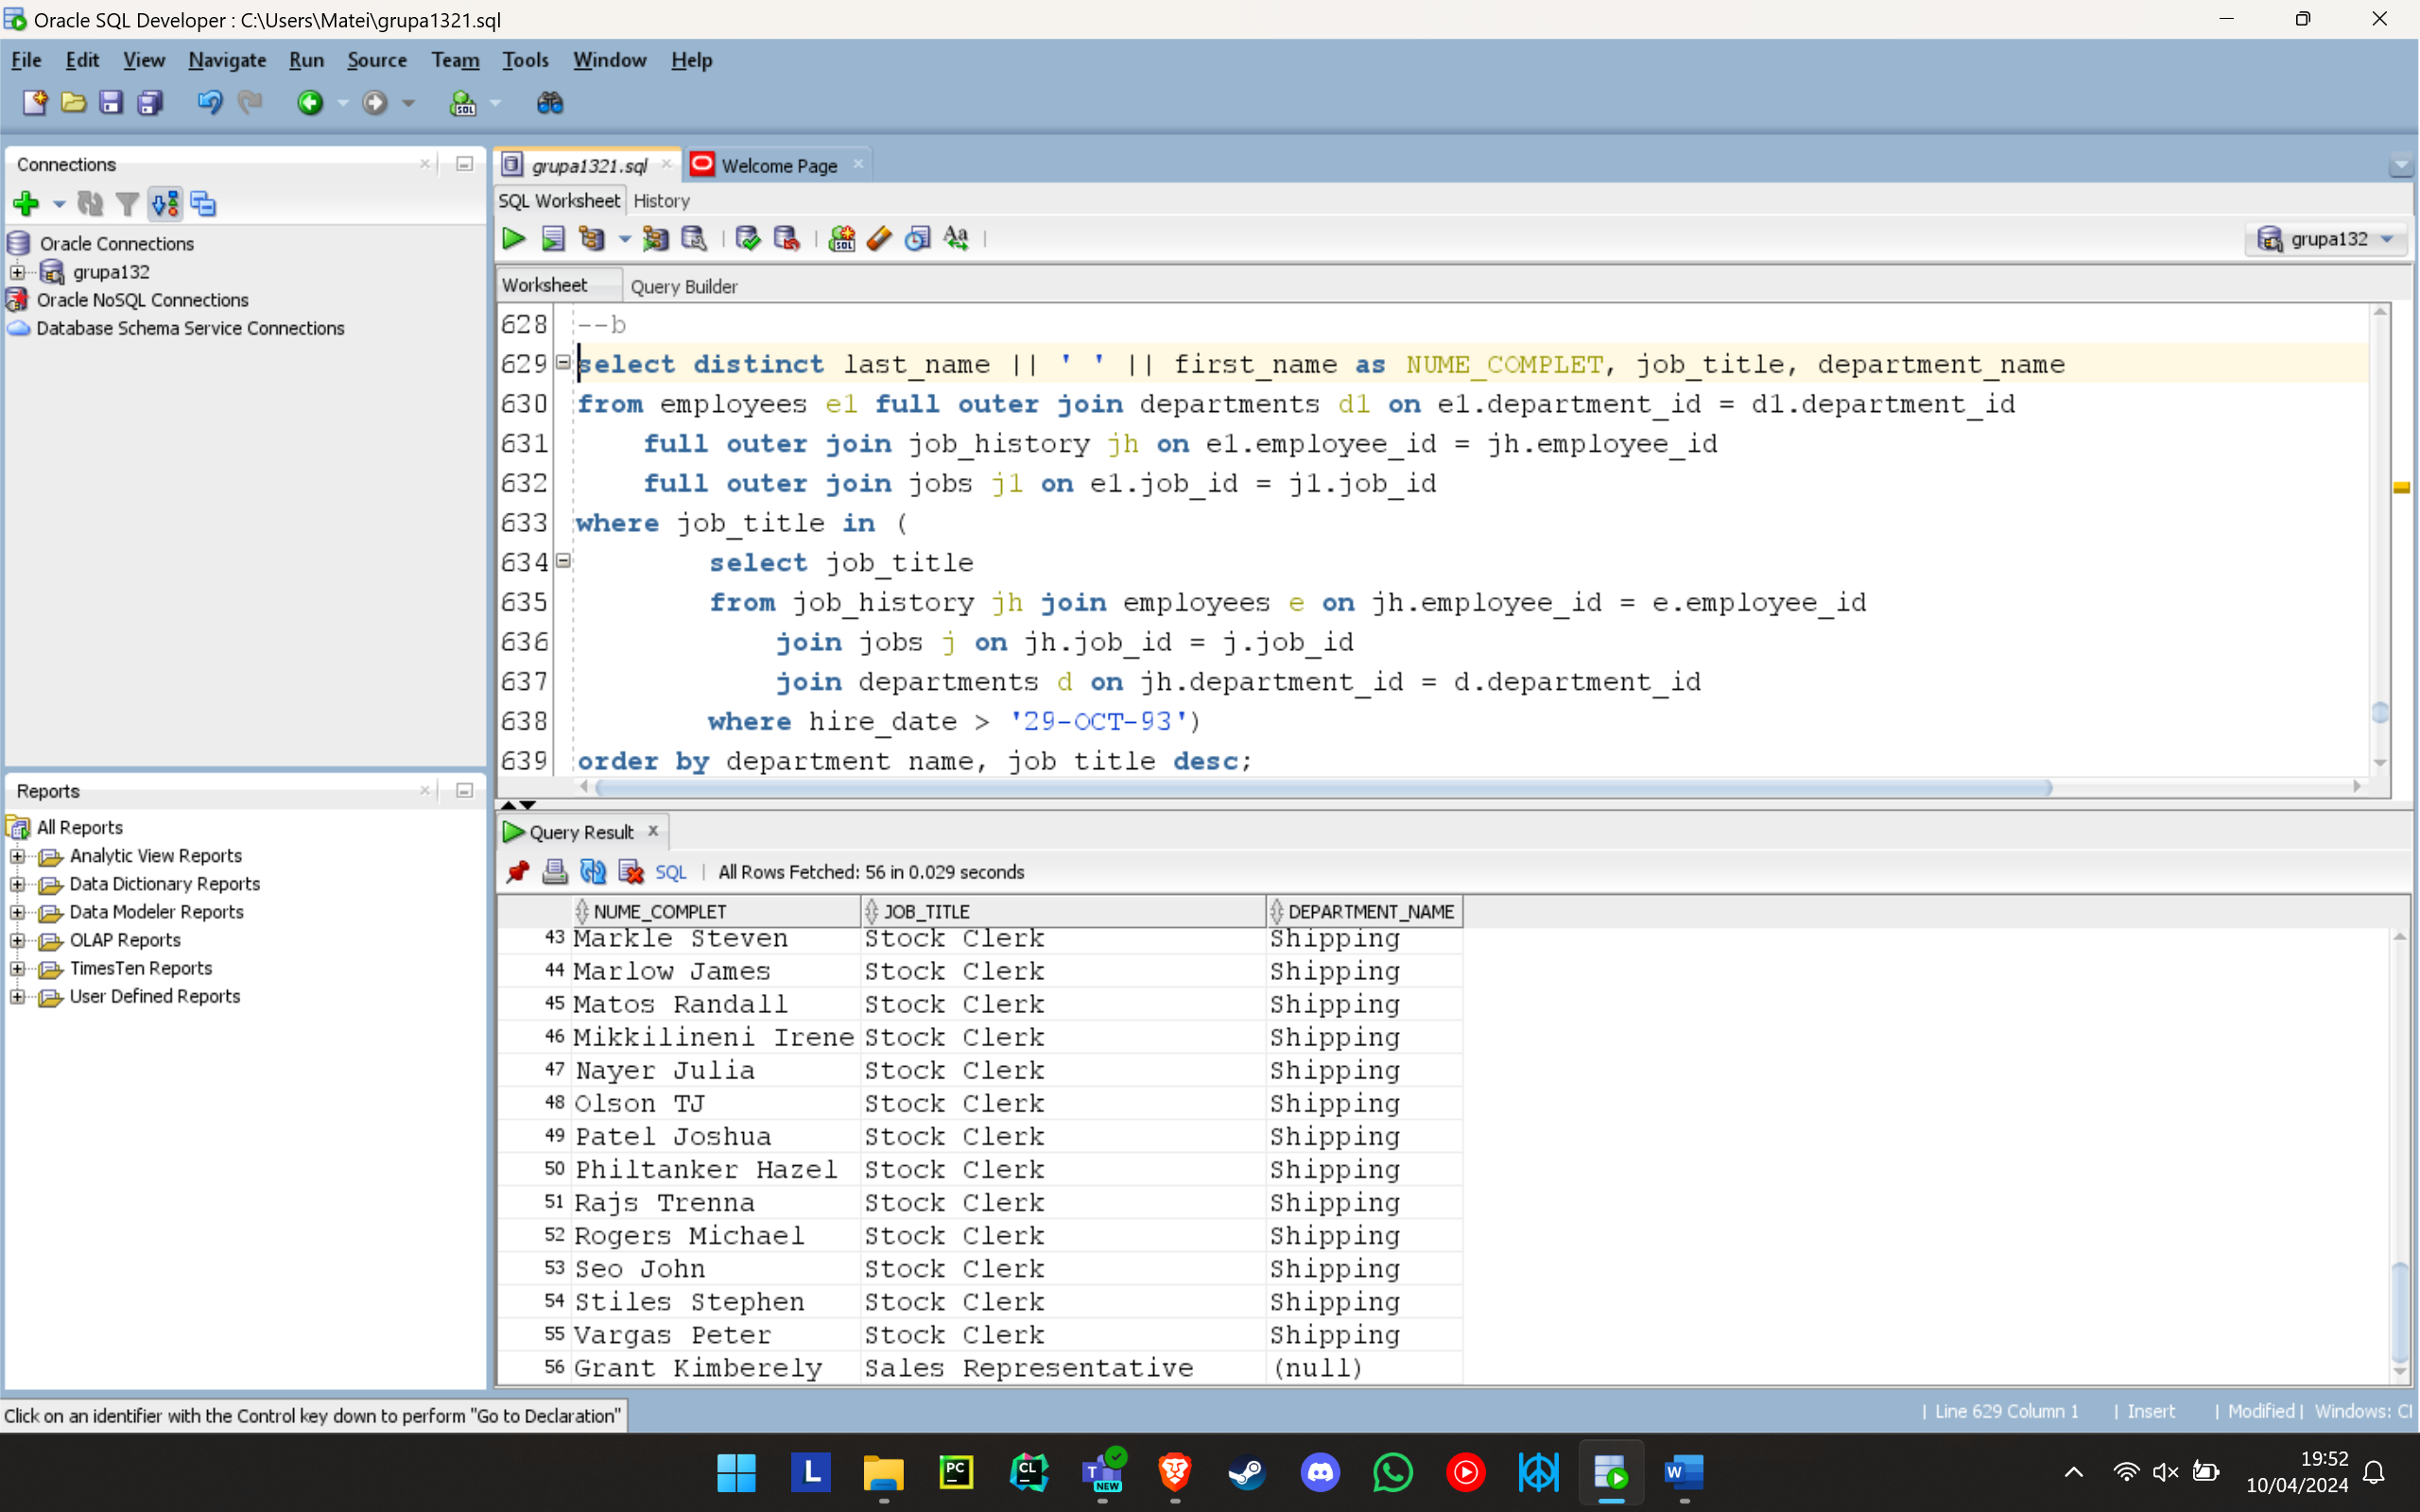

Ex2c): Sa se afiseze numele complet, job-ul (titlul) actual si departamentul (numele) actual

pentru angajatii care in prezent lucreaza intr-un departament sau pe un job

pe care au lucrat in trecut si alti salariati angajati dupa 29-Octombrie-1993. Discutati diferentele aparute in cod, cat si despre rezultatele obtinute.

select distinct last_name || ' ' || first_name as NUME_COMPLET, job_title, department_name

from employees e1 full outer join departments d1 on e1.department_id = d1.department_id

full outer join job_history jh on e1.employee_id = jh.employee_id

full outer join jobs j1 on e1.job_id = j1.job_id

where job_title in (

select job_title

from job_history jh join employees e on jh.employee_id = e.employee_id

join jobs j on jh.job_id = j.job_id

join departments d on jh.department_id = d.department_id

where hire_date > '29-OCT-93')

or department_name in (

select department_name

from job_history jh join employees e on jh.employee_id = e.employee_id

join jobs j on jh.job_id = j.job_id

join departments d on jh.department_id = d.department_id

where hire_date > '29-OCT-93')

order by department_name, job_title desc;

--82 rezultate

Apar in plus fata de cerinta a) inca 27 angajati care lucreaza in acelasi departament sau job ca alti salariati angajati dupa 29 oct 1993

